भारत मौसम विज्ञान विभाग |  | India Meteorological Department
Sunday 10th May 2026 (20th Vaisakha 1948 Saka)
Summary of observations recorded at 0830 hours IST: The Western Disturbance as a trough in middle and upper tropospheric westerlies with its axis at 5.8 km above m. s. l. ran roughly along Long. 56°E to the north of Lat. 32°N. The upper air cyclonic circulation over Sub-Himalayan West Bengal & neighbourhood between 1.5 and 5.8 km above m. s. l. persisted. The upper air cyclonic circulation over East Rajasthan lay over southeast Rajasthan & neighbourhood at 0.9 km above m. s. l. The upper air cyclonic circulation over West Uttar Pradesh & neighbourhood lay over southern parts of central Madhya Pradesh at 1.5 km above m. s. l. The trough from the upper air cyclonic circulation over East Rajasthan to East Jharkhand ran from the upper air cyclonic circulation over southeast Rajasthan & neighbourhood to Gangetic West Bengal across Madhya Pradesh, Chhattisgarh & Jharkhand at 0.9 km above m. s. l. An upper air cyclonic circulation lay over northeast Bangladesh & neighbourhood at 1.5 km above m. s. l. A north-south trough ran from north Pakistan and adjoining Punjab to Marathwada across upper air cyclonic circulation over southeast Rajasthan & neighbourhood, Madhya Pradesh & Madhya Maharashtra at 0.9 km above m. s. l. The trough in middle and upper level westerlies with its axis at 7.6 km above m. s. l. ran from northeast Bihar to central parts of Coastal Andhra Pradesh across Jharkhand, Odisha & Chhattisgarh. The trough in easterly from southeast Arabian Sea & adjoining Lakshadweep off Kerala coast to Marathwada ran from North Interior Karnataka to the upper air cyclonic circulation over Gulf of Mannar and adjoining Sri Lanka Kerala coast across South Interior Karnataka and Tamil Nadu at 0.9 km above m. s. l. The upper air cyclonic circulation over Comorin area & neighbourhood lay over Gulf of Mannar and adjoining Sri Lanka extending upto 5.8 km above m. s. l. at 0830 hrs IST of today the 09th May 2026. It then persisted over the same region. Under its influence a low-pressure area is likely to form over Southwest Bay of Bengal around 11th May, 2026. The upper air cyclonic circulation over southeast Arabian Sea & adjoining Lakshadweep off Kerala coast became less marked at 0530 hrs IST of today morning. The upper air cyclonic circulation over East Madhya Pradesh & neighbourhood became less marked at 0530 hrs IST of today morning.
Maximum Temperature Departures: Yesterday, Maximum temperatures were markedly below normal (< -5.1°C) at isolated places over Uttar Pradesh & Tamil Nadu; appreciably below normal (-3.0°C to -5.0°C) at many places over Uttar Pradesh, Bihar, Punjab, Haryana & Delhi, interior Odisha, Tamil Nadu, at isolated places over Chhattisgarh, Jharkhand, Gangetic West Bengal, Coastal Andhra Pradesh; below normal (-1.6°C to -3.0°C) at remaining parts of Gangetic West Bengal, Odisha; many places over East Madhya Pradesh, Telangana, Vidarbha; isolated places over coastal Kerala & Andhra Pradesh. They were markedly above normal (> 5.1°C) at few places over Arunachal Pradesh and Jammu-Kashmir-Ladakh; at isolated places over West Madhya Pradesh and Saurashtra & Kutch; appreciably above normal (3.1°C to 5.0°C) at many places over Gujarat Region; at few places over Assam & Meghalaya and West Rajasthan; at isolated places over Nagaland, Manipur, Mizoram & Tripura, Gangetic West Bengal, East Rajasthan and Konkan & Goa; above normal (1.6°C to 3.0°C) at few places over Madhya Maharashtra and Coastal Karnataka; at isolated places over Sub Himalayan West Bengal & Sikkim and North Interior Karnataka. The highest maximum temperature of 45.7°C is reported at Barmer (Rajasthan).
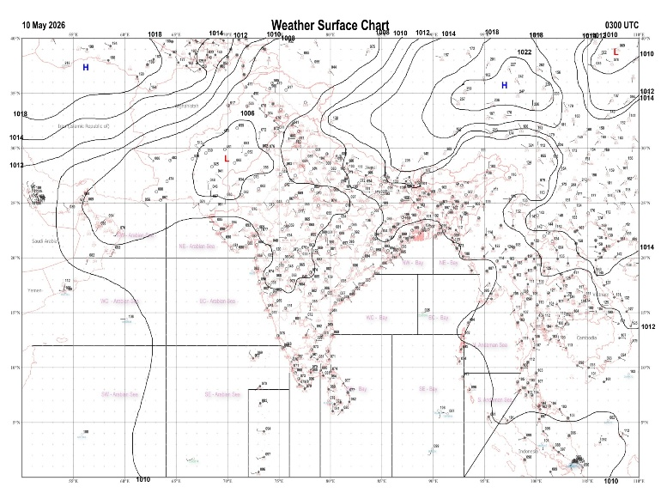 | 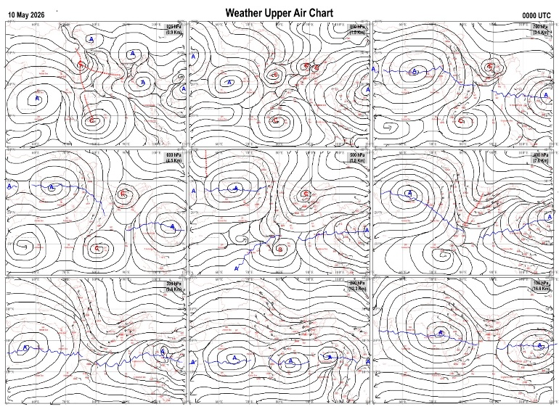
Fig.1. Analysed surface chart based on 03z observation | Fig.2. Analysed upper air chart based on 00z observation
V.K.Shripad
Scientific Officer ‘I’
CR & S Office, Pune  Issued at 1245 hrs. IST |  | Weather Forecasting Division  CR&S, Pune

Indian regions | Realised rainfall (chief amount in cm during past 24 hrs):
East | a few places: Gangetic West Bengal  isolated places: Arunachal Pradesh, Assam & Meghalaya, Nagaland-Manipur-Mizoram-Tripura, Sub-Himalayan West Bengal & Sikkim, Odisha, Jharkhand and Bihar  Canning 5.9, Berhampore 4.5, Amtala & Bargarh 4.2 each, Ghasipura 3.7, Lava 3.6, Jalalgarh 3.5, Chanan 3.2, Bokaro thermal 2.1, Jamshedpur 2.0, Bano simdega kvk AWS & Gaya AP 1.9 each, Gangtok 1.8, Malda 1.6, Tihu ARG 0.9, Zunheboto & Titlagarh 0.6 each, Baghmara AWS 0.5, Tawang 0.4, Mukto ARG & Chandel 0.3 each, Barapani 0.2.
North | isolated places: Uttarakhand◆  dry weather: Uttar Pradesh, Haryana, Punjab, Himachal Pradesh, Jammu-Kashmir and Ladakh and Rajasthan  Tharali 0.2.
Central | isolated places: Madhya Pradesh, Vidarbha and Chhattisgarh  Manendragarh 2.7, Pendra road & Mana-Raipur-AP 2.5 each, Pushprajgarh 1.4, Amarkantak 1.3, Salwani 0.5, Chandrapur 0.4, Mungaoli & Gadchiroli 0.2 each, Vidisha, Seoni & Tiroda (ARG) 0.1 each.
Peninsula | many places: Tamil Nadu+++ and Kerala+++  a few places: coastal and south interior Karnataka  isolated places: Gujarat Region◆, Konkan & Goa, Madhya Maharashtra, Marathwada◆, coastal Andhra Pradesh, Telangana, Rayalaseema and north interior Karnataka  dry weather: Saurashtra & Kutch  Oothu 17.3, Nalumukku 16.4, Hosdurg 13.6, Madikkai AWS 10.8, Pamban 7.1, Aswaraopeta 4.8, Tala 4.2, Sudhagad pali 3.8, Gudurwrgl 3.6, Konanur & Punalur 3.4 each, Sulya 2.4, H d kote 2.1, Lonavala ARG 1.5, Gudivada & Mangaluru 1.4 each, Chintamani PTO 1.1, Londa 0.8, Ratnagiri , Nuzvid & Satyavedu 0.7 each, Masulipatnam cdr 0.5, Srikalahasti 0.4, Bilgi (irri.) 0.3, Jeur IMD parttime, Sambhajinagarobsy & Mahbubnagar 0.2 each, Silvassa & Shakti Nagar 0.1 each.
Islands | most places: Andaman & Nicobar  a few places: Lakshadweep  Maya bandar 5.1, Port blair 3.8, Long island 3.3, Agathi 2.4, Amini 0.2.
Table-2 Forecast / warnings (distribution of rain / thundershowers) for 7 days (valid from time of origin upto 0830 hrsIST of next day)
Sr N. |  | Sub-division Name | Day 1 | Day 2 | Day 3 | Day 4 | Day 5 | Day 6 | Day 7 | Sr. No. | Sub-division Name | Day 1 | Day 2 | Day 3 | Day 4 | Day 5 | Day 6 | Day 7
 |  |  | 10 May | 11 May | 12 May | 13 May | 14 May | 15 May | 16 May |  |  | 10 May | 11 May | 12 May | 13 May | 14 May | 15 May | 16 May
 | 1 | Andaman Nicobar Islands | F + | F | F | F | F + | F + | F + | 19 | west Madhya Pradesh | I  | D | D + | D + | D + | D | D
 | 2 | Arunachal Pradesh | S | S | S  | F  | W + | F | F | 20 | east Madhya Pradesh | I  | D | D | D | D | D | D
 | 3 | Assam-Meghalaya | S +  | S +  | F  | F +  | W +  | W + | W + | 21 | Gujarat region | D + | D + | D + | D + | D + | D | D
 | 4 | Nagaland-Manipur-Mizoram-Tripura | S  | S  | S  | S  | S  | F + | F + | 22 | Saurashtra and Kutch | D + | D + | D + | D + | D + | D | D
 | 5 | Sub Him West Bengal/Sikkim | F  | S  | W +  | W +  | W +  | F | F | 23 | Konkan and Goa | I + | D + | D | D | D | D | D
 | 6 | Gangetic West Bengal | F  | I  | I | S | S | I | I | 24 | Madhya Maharashtra | I  | I  | D | D | D | D | I
 | 7 | Odisha | I  | I  | I  | I | I | I | I | 25 | Marathwada | I  | I  | I | D | D | D | I
 | 8 | Jharkhand | S  | I  | I  | S  | I  | I  | I  | 26 | Vidarbha | I  | I  | D | D | D | D | D
 | 9 | Bihar | I  | I  | S  | I  | I  | I | I | 27 | Chhattisgarh | I  | I  | I  | I  | I  | I | I
 | 10 | east Uttar Pradesh | I | I | I | I  | I  | I | D | 28 | Coastal Andhra Pradesh and Yanam | I  | I  | I  | I  | I  | I | I
 | 11 | west Uttar Pradesh | D | D | I  | I  | I | D | D | 29 | Telangana | I  | I  | D | D | D | D | D
 | 12 | Uttarakhand | I | S  | F | F | S  | I | I | 30 | Rayalaseema | I  | I  | I | I | I  | I | I
 | 13 | Haryana,Chandigarh and Delhi | I  | I  | I  | I  | I  | D | D | 31 | Tamil Nadu, Puducherry and Karaikal | S +  | S +  | I +  | I +  | I +  | S + | S +
 | 14 | Punjab | I  | I  | I  | I  | I  | D | D | 32 | Coastal Karnataka | S  | I  | I  | I  | I  | I | I
 | 15 | Himachal Pradesh | D | S  | F | F | F  | S | I | 33 | North interior Karnataka | I  | I  | I  | I  | I  | I | I
 | 16 | Jammu-Kashmir and Ladakh | F + | W | F | I  | I | I | I | 34 | South interior Karnataka | I  | I  | I  | I  | I  | I | I
 | 17 | west Rajasthan | D + | D+  | I + | D + | D + | D | D | 35 | Kerala and Mahe | W+ | F +  | F+ | F+  | W+ | W + | W +
 | 18 | east Rajasthan | D + | I + | I + | I + | I | D | D | 36 | Lakshadweep | F+ | F  | F | F | F | F | F
Legends: D = Dry I =isolated S = Scattered F = Fairly widespread W = Widespread #= heavy to very heavy rain at a few places with extremely heavy rain at isolated places+++= heavy rain at a few places with very heavy rain at isoIated places++= heavy to very heavy rainfall @=isolated exceptionally heavy rainfall+ = heavy rain ●/*= rain or snow ♦ = very light rain ≡=fog = thunderstorm with lightning =Squall / Gusty / gale / strong wind -=cold wave/cold day + = heat wave/warm night/hot and humid weather =Duststorm =ground frost = Hail.
Fig. 4: Districtwise warnings for five days for Maharashtra State
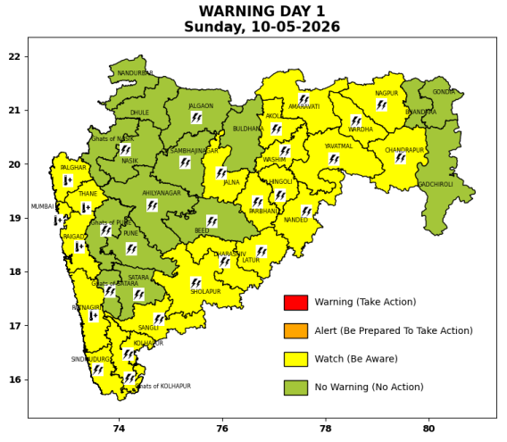 | 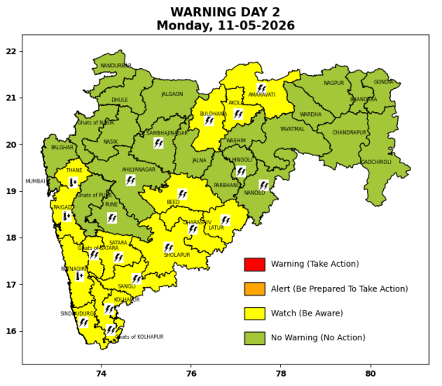 | 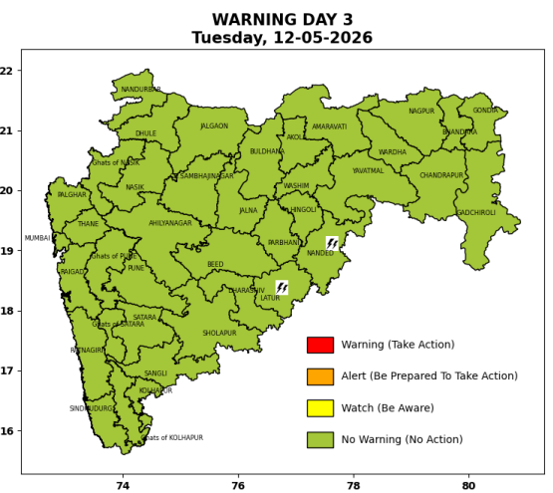 | 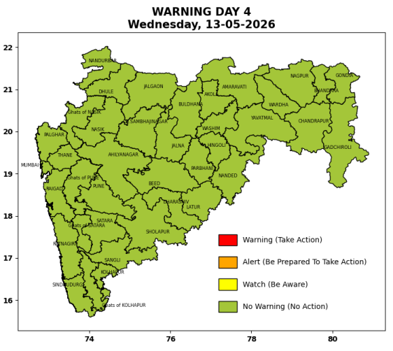 | 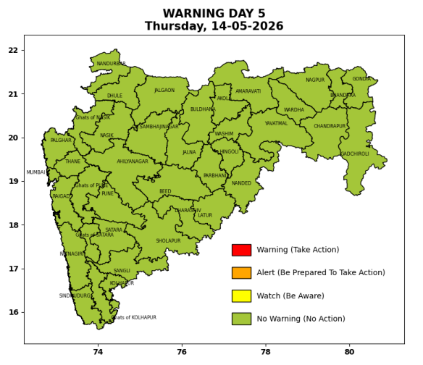

Pune, Lohegaon and Pashan observations at 0830 hrs. IST of Today
 | Temperature (°C) |  |  |  |  | Humidity (%) |  |  |  | Rainfall (mm)
 | Max.  past  24 hrs | Dep.  from  normal | Min.  past  24 hrs. | Dep.  from  normal | Dry  Bulb | At 0830 hrs. IST | Dep.  From  normal | At 1730  hrs. IST of y’day | Dep.  from  normal | Past  24 hrs. | Since  1st March | Dep.  from  normal
PNE | 38.6 | 0.6 | 21.7 | -0.9 | 30.4 | 48 | -8 | 44 | 12 | 0.0 | 92.8 | 72.4
PSN | - | - | - | - | - | - | - | - | - | - | - | -
LHG | 40.3 | 2.3 | 25.6 | 4.6 | 32.6 | 33 | -22 | 34 | 4 | 0.0 | 91.4 | 65.4

 |  |  |  |  |  |  | Local (Pune and neighbourhood) forecast
Max./Min. Temperature (°C) |  |  |  |  |  |  |  |  | Weather
Date | Pune | Pashan | Lohegaon | Chinchwad | Lavale | Magarpatta | NDA | Koregoan park
10/05/26 | 41 / 21.7* | 40 / - | 42 / 25.6* | 39 / 24.8* | 40 / 22.2* | 39 / 26.4* | 38 / 20.3* | 42 / 25.3* | Mainly clear sky becoming partly cloudy sky towards afternoon or evening.
11/05/26 | 40 / 22 | 39 / 21 | 41 / 26 | 39 / 25 | 39 / 22 | 39 / 26 | 38 / 20 | 41 / 25 | Mainly clear sky becoming partly cloudy sky towards afternoon or evening.
12/05/26 | 40 / 22 | 39 / 21 | 41 / 26 | 39 / 25 | 39 / 22 | 39 / 26 | 38 / 20 | 41 / 25 | Mainly clear sky becoming partly cloudy sky towards afternoon or evening.
13/05/26 | 41 / 23 | 40 / 22 | 42 / 27 | 40 / 26 | 40 / 23 | 40 / 27 | 39 / 21 | 42 / 26 | Mainly clear sky becoming partly cloudy sky towards afternoon or evening.
14/05/26 | 41 / 23 | 40 / 22 | 42 / 27 | 40 / 26 | 40 / 23 | 40 / 27 | 39 / 21 | 42 / 26 | Mainly clear sky becoming partly cloudy sky towards afternoon or evening.
15/05/26 | 41 / 22 | 40 / 21 | 42 / 26 | 40 / 25 | 40 / 22 | 40 / 26 | 39 / 20 | 42 / 25 | Mainly clear sky becoming partly cloudy sky towards afternoon or evening.
16/05/26 | 40 / 22 | 38 / 21 | 41 / 26 | 39 / 25 | 39 / 22 | 39 / 26 | 38 / 20 | 41 / 25 | Mainly clear sky becoming partly cloudy sky towards afternoon or evening.
Rainfall Distribution |  |  |  |  | Rainfall Categories | Rainfall (mm) | Cloud condition |  | Rainfall Intensity | Range
Widespread (W) | 76-100% |  |  |  | Very Light rain | Trace to 2.4 mm | Mainly clear sky | 1-2 oktas | Light Spell | 1 cm/hr
 |  |  |  |  | Light rain | 2.5 to 15.5 mm | Partly cloudy sky | 3-4 oktas | Moderate Spell | 1-2 cm/hr
Fairly Widespread (FW) | 51 – 75% |  |  |  | Moderate rain | 15.6 to 64.4 mm | Generally cloudy sky | 5-7 oktas | Intense Spell | 2-3 cm/hr
Scattered (S) | 26 – 50% |  |  |  | Heavy rain | 64.5 to 115.5 mm | Overcast | 8 oktas | Very Intense Spell | 3-5 cm/hr
Isolated (I) | 1 – 25% |  |  |  | Very heavy rain | 115.6 to 204.4 mm |  |  | Extremely Intense Spell | 5-10 cm/hr
Dry (D) | No Rain |  |  |  | Extremely heavy rain | ≥ 204.5 mm |  |  | Cloudburst | > 10 cm/hr
Probability Terms in %: |  |  |  |  | Heavy snow | 6.5 to 11.5 cms water equivalent of rain
unlikely | < 25 |  |  |  | Very heavy snow | 11.6 to 20.4 cms water equivalent of rain
likely | between 25 50
very likely | between 51 75
most likely | >75
* = realized temperatu
Mumbai (Colaba) |  |  |  | Nagpur (AP)
Date 2026 | T max °C | T min °C | Weather | T max °C | T min °C | Weather
10/05/26 | 35 | 26 | Mainly clear sky. Hot and Humid. | 42 | 23 | Thunderstorm with rain. Thunderstorm accompanied with lightning & gusty winds(40-50kmph).
11/05/26 | 34 | 26 | Mainly clear sky. | 43 | 24 | Partly cloudy sky.
12/05/26 | 34 | 27 | Partly cloudy sky towards afternoon or evening. | 44 | 24 | Partly cloudy sky.
13/05/26 | 35 | 27 | Partly cloudy sky towards afternoon or evening. | 44 | 25 | Partly cloudy sky.
14/05/26 | 35 | 26 | Mainly clear sky. | 44 | 25 | Mainly clear sky.
15/05/26 | 35 | 26 | Clear sky. | 44 | 26 | Mainly clear sky.
16/05/26 | 35 | 26 | Clear sky. | 44 | 26 | Partly cloudy sky.

